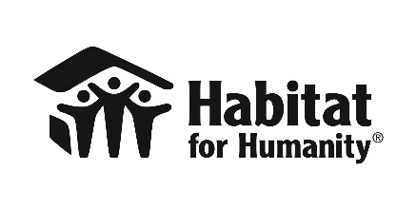

Habitat for Humanity Statement to the Global Platform for Disaster Risk Reduction 2017
Cancun, Mexico May 22-26 2017

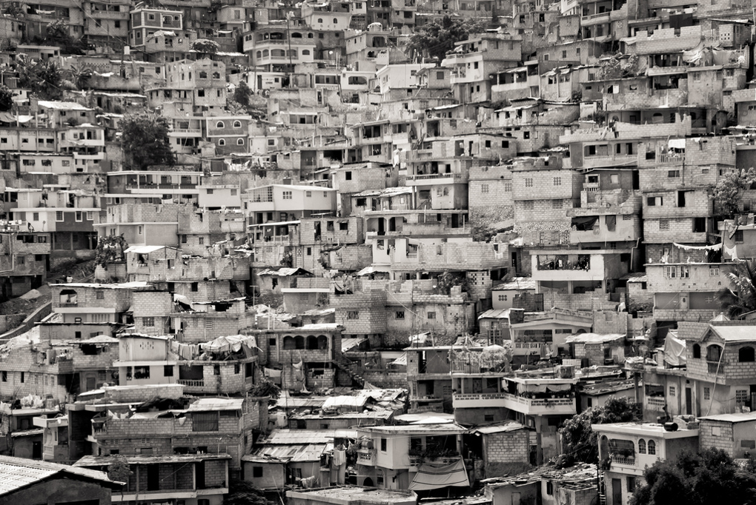

Our involvement with global agendas

Habitat for Humanity International expresses our support and commitment to the implementation of the Sendai Framework for Disaster Risk Reduction 2015-2030. As a civil society movement, Habitat for Humanity has contributed and engaged with partners on this global initiative as well as other global agendas, including commitments to the World Humanitarian Summit and influencing the primary outcome document of Habitat III, the New Urban Agenda.

At the World Humanitarian Summit held in Istanbul, Turkey in May 2016, Habitat made several pledges reaffirming our commitment to improve our work towards the alleviation of human suffering and the reduction of risk and vulnerability. Habitat for Humanity International and its local, affiliated partners in more than 70 countries place peoples’ humanity at the center of our decision-making.

At Habitat III, celebrated in Quito, Ecuador in October 2016, Habitat made the following commitments:

- Habitat introduced a new urban approach to promote inclusive and sustainable cities in a highly urbanizing world.

- Habitat launched an advocacy campaign to raise awareness and improve policies and systems to help 10 million people secure access to land for shelter, focusing on four key areas: secure tenure, slum upgrading, disaster resilience and gender equality.

- Habitat launched the Terwilliger Center for Innovation in Shelter to accelerate and facilitate better functioning, inclusive housing markets to enable access to improved shelter solutions for over 8 million people by 2020.

- Habitat will implement an array of community development strategies, advocacy initiatives and market approaches to increase access to affordable housing for nearly 40 million people by 2020.

Habitat recognizes that the success of implementation of these global agendas totally depends on meaningful participation of all involved stakeholders, especially at the local level. Involvement of local communities, government and civil society in the conceptualization, design, implementation and monitoring of policies, standards and plans is key to achieve sustainable disaster resilience.

Our commitments to the Sendai Framework for Disaster Risk Reduction

Habitat for Humanity commits to the following actions in support of the implementation of the Sendai Framework for Disaster Risk Reduction:

- Address disaster risk reduction in all shelter, housing and settlements programming with an emphasis on the causal and underlying factors of disasters by promoting interventions that address the exposure to hazards, reduce vulnerability of people and property, facilitate the wise management of land and the environment, improve preparedness for adverse events and promote adaptations to climate change.

- Work together with civil society organizations and local governments to build safer and more resilient communities, promoting a culture of preparedness and understanding that secured land tenure, affordable housing, safe water and sanitation are critical components to foster disaster risk reduction.

- Improve the internal capacity of local Habitat affiliated entities and partners in order to serve the most vulnerable populations, with a strong emphasis on urban areas given their exponential growth and high exposure to risk.

- Support disaster risk reduction as a national and local priority, contributing to strong governance and participation of vulnerable populations in the decision-making process by fostering safe shelter and settlements awareness, strengthening local leadership and promoting gender balance.

Going Forward—Our Call to Governments

To support delivery of these commitments, Habitat for Humanity calls on all governments to:

- Enact adequate and effective laws and regulations that apply to disaster risk reduction and facilitate sound planning, land use, finance, access to services, design and construction of safe shelter and settlements, environmental management and climate change adaptions.

- Increase national government funding for disaster risk reduction to mitigate the rising cost of humanitarian assistance and economic losses by the impacts of disasters, recognizing that investments in prevention far offset the costs of disaster response.

- Implement regulations that ensure security of tenure, particularly for affected populations, to safeguard continued access to safe land and rebuilding without fear of eviction before or after a disaster, within a framework for sustainable development.

- Engage local government officials with vulnerable communities, making them active participants as decision-makers and first responders when addressing local needs, applying community-based disaster risk reduction mechanisms and integrated approaches to improve the lives of vulnerable populations, develop capacity and raise awareness on shelter and settlements related risks.

Contact: Mario Flores (mflores@habitat.org), Jane Katz (jkatz@habitat.org), Jaime Mok (jmok@habitat.org)

